**Be careful when choosing a domain name!**

In theory, choosing a domain name is a simple task. It has to be short, clever, memorable, easy to spell and communicate your business message.

Let’s say you’ve done an awesome job choosing a domain name and now you are ready to register it.

Wait! Look again. Are you sure there are no unintended messages or dirty words hiding in the letters of longer words and their combinations?

So, just for a while, forget your company name and the words you’ve used in your domain name. Look at it with fresh eyes…

**How NOT to choose a domain name…**

**Therapist.com 
One of the most cringeworthy domain names we've ever come across.**

* Need a therapist?



* [**choosespain.com**](http://Choosespain.com)

Chooses pain

[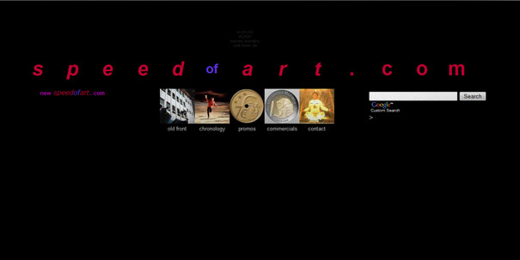](http://speedofart.com/)

* **speedofart.com**
* **whorepresents.com** Need to know who represents what… or…???